# CS 419 Compiler Project Form

**Project Idea: Project 1**

**Team Members NO#:** 22

|  |  |  |  |  |  |
| --- | --- | --- | --- | --- | --- |
| **ID** | **Name** | **Level& Department** | **Section(Day- from-to)** | **Role (Lead/Member)** | **Grade** |
| 201900129 | اسراء علي عبد القادر | 3 & CS | الاربع من 10-12 | Leader |  |
| 201900010 | ابراهيم محمد السادات | 3 & CS | الاربع من 10-12 | Member |  |
| 201900034 | احمد رجب نفادى احمد | 3 & CS | الاربع من 10-12 | Member |  |
| 201900347 | سلمى خالد محمد الصاوى | 3 & CS | الاربع من12-2 | Member |  |
| 201900883 | مينا ميلاد جرجس حنين | 3 & CS | الاربع من 2-4 | Member |  |
| 201900156 | اشرقت محمد ابو العلا محمد | 3 & CS | الاربع من 10-12 | Member |  |
| 201900212 | اية وحيد محمد فرج | 3 & CS | الأربع من 12-2 | Member |  |

## Regular Expression, Finite automata and Conversion from RegX to NFA, NFA to DFA

**If – Else**

**RE : (If | Else)**

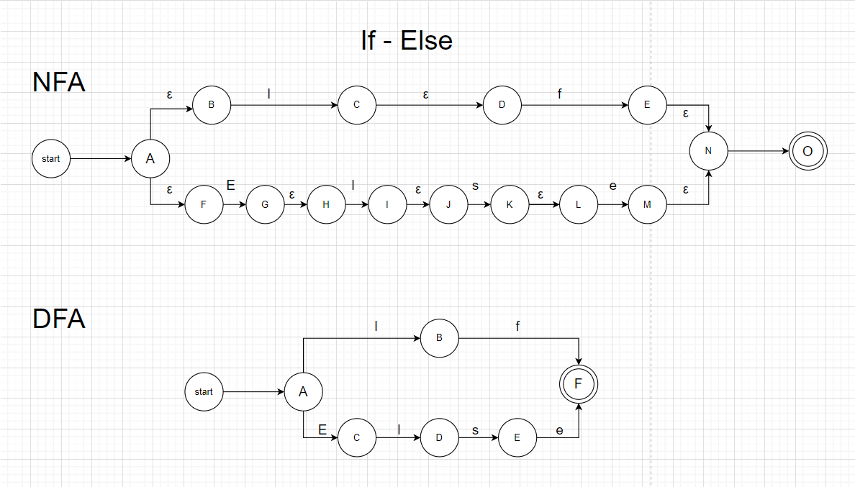

**Iow**

**RE: (Iow)**

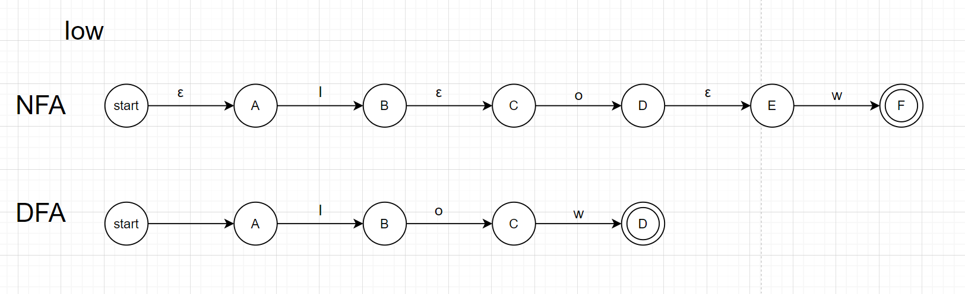

**Slow**

**RE: (Slow)**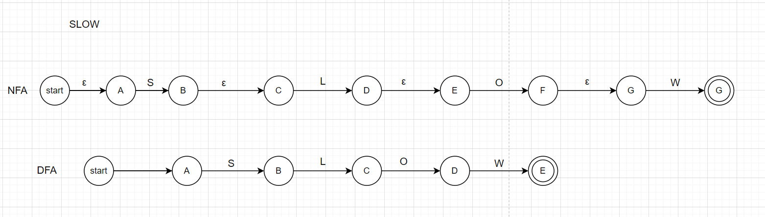

**Chlo**

**RE : (Chlo)**

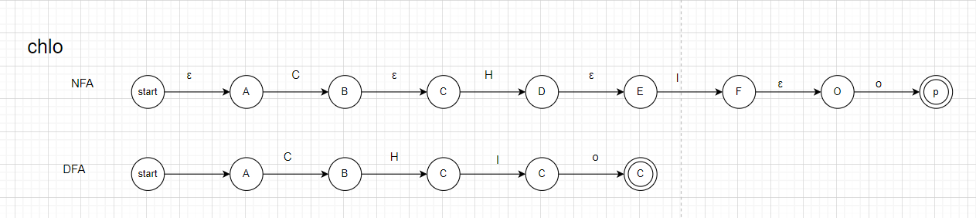

**Chain**

**RE:(Chain)**

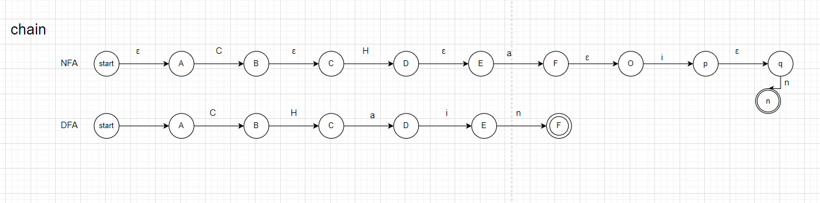

**Iowf**

**RE: (Iowf)**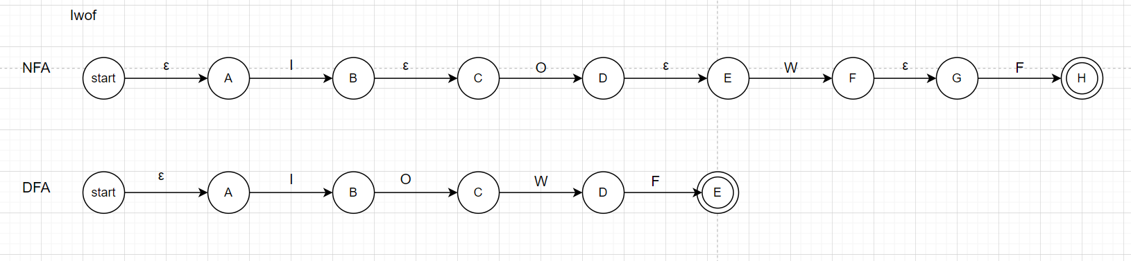

**Slow**

**RE: (Slow)**

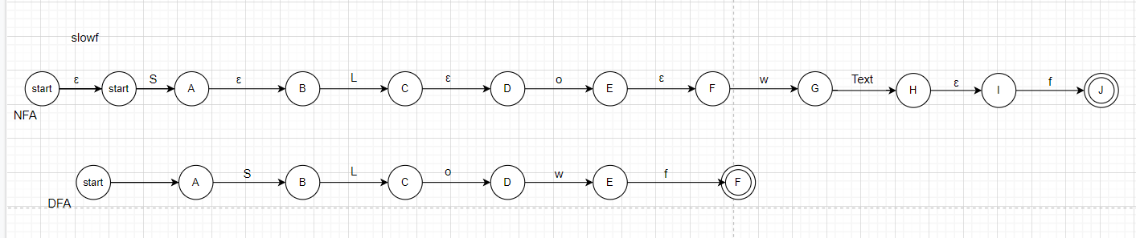

**Worthless**

**RE: (Worthless)**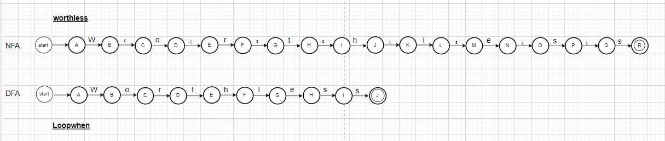

**Turnback**

**RE: (Turnback)**

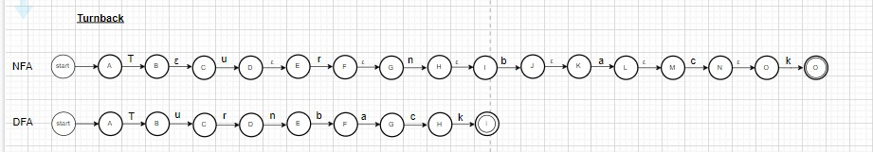

**Loopwhen / Iteratewhen**

**RE: (Loopwhen | Iteratewhen)**

**Stop**

**RE: (Stop)**

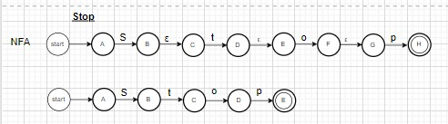

**Loli**

**RE: (Loli)**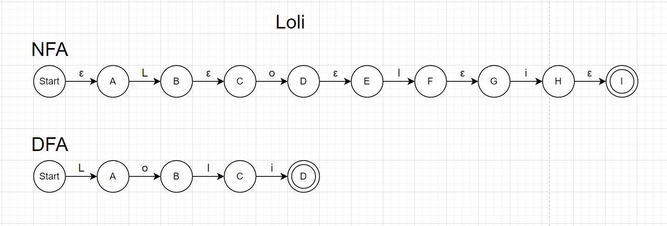

**( + , - , * , / )**

**RE: ( \+ | \- | \* | / )**

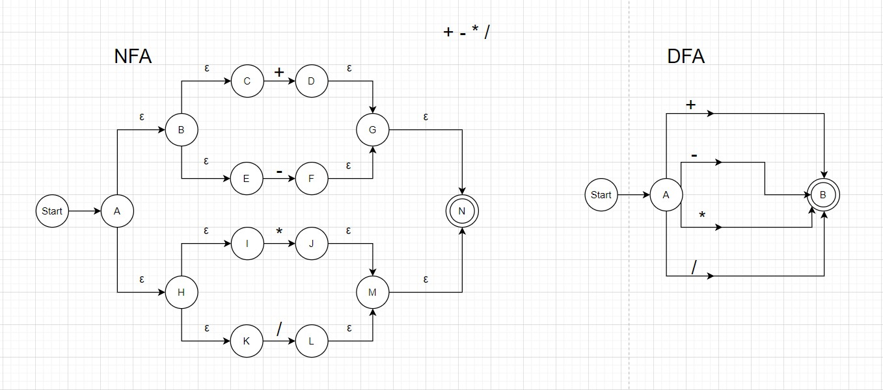

**( && , || , ~ )**

**RE: (\&& | \|| | \~)**

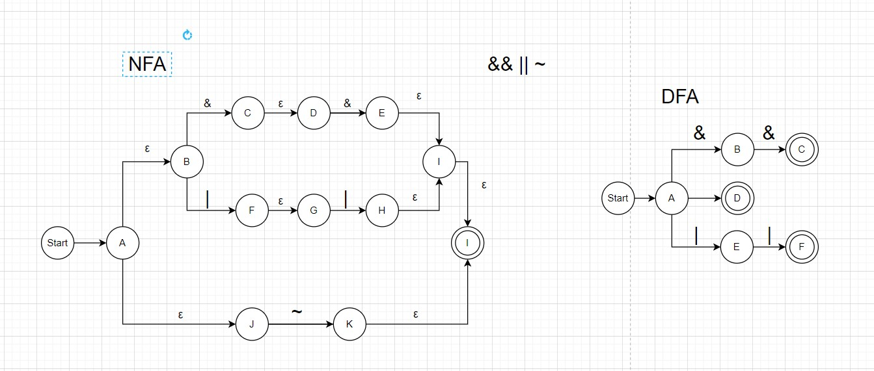

**(=)**

**RE: (=)**

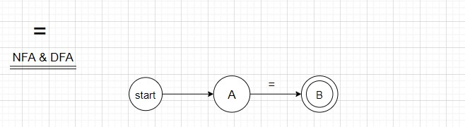

**( == , < , > , != , <= , >= )**

**RE: (( == | != ) | ( =* | ( < | > ) )**

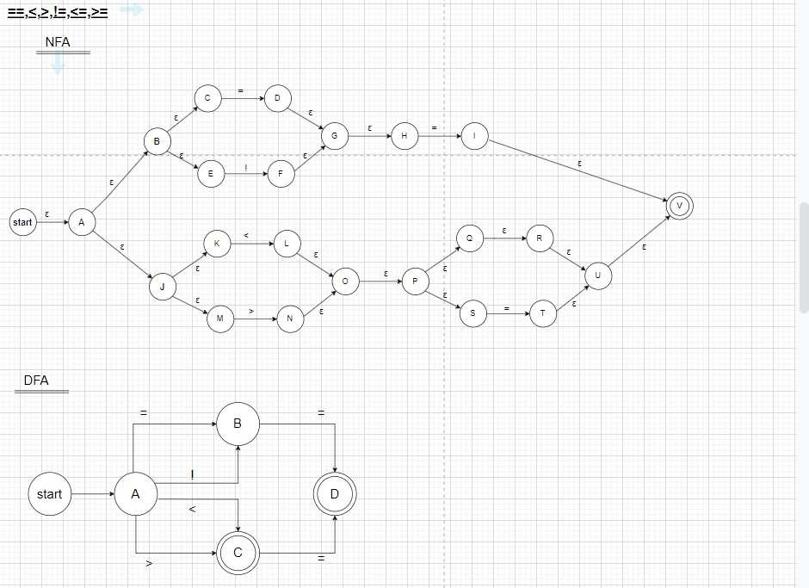

**( -> )**

**RE: ( -> )**

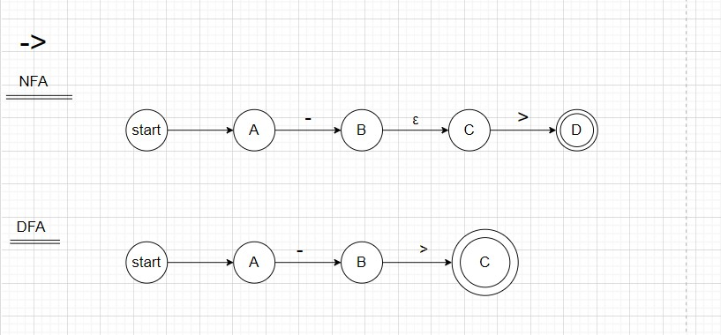

**( Include )**

**RE: (Include)**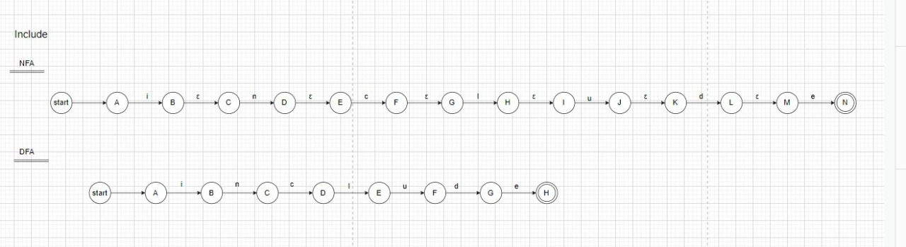

**( “ , ’ )**

**RE: ( “ |**

**( [ 0-9 ] ) and any combination**

**RE: ( [ 0-9 ] )**

**RE2: (\d+)**

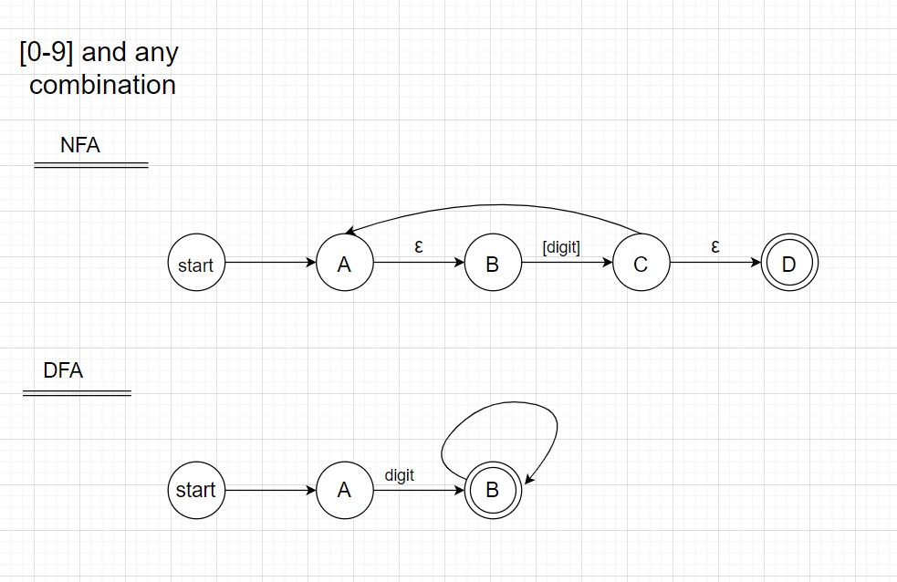

**( { , } , [ , ] )**

**RE: ( ( { , } ) | ( [ , ] ) )**

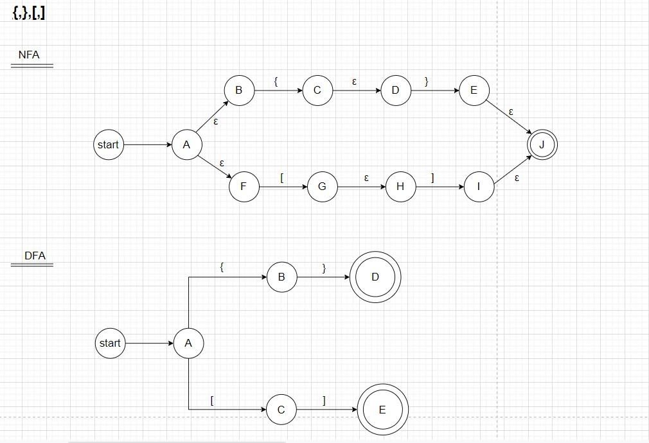

**Identfier**

**RE: ( [letter][letter|digit]* )**

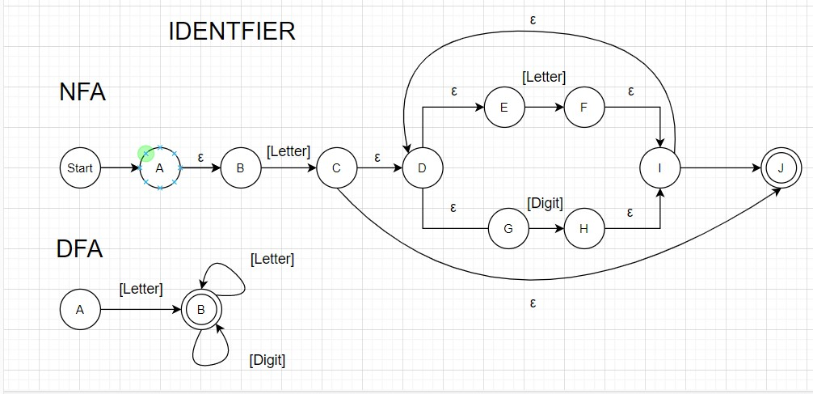

**Full DFA**

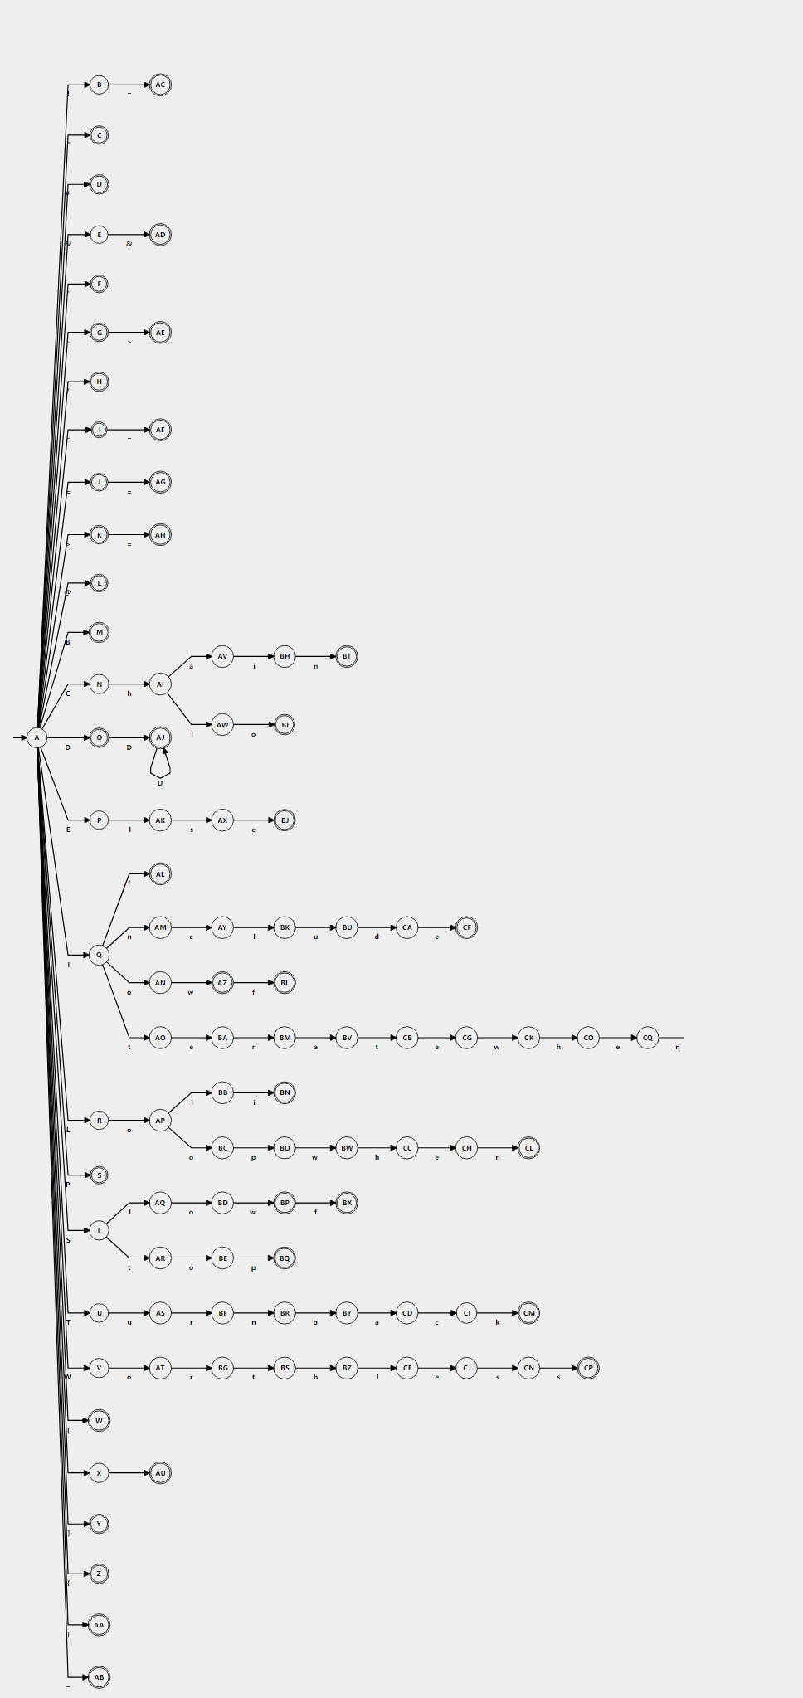

**Parse tree and Abstract syntax tree**